- A number is chosen at random from 1 to 10. Find the probability of selecting a multiple of 2 or a multiple of 3.

- A number is chosen at random from 1 to 10. Find the probability of selecting a multiple of 2.

- A number is chosen at random from 1 to 50. Find the probability of selecting multiples of 10.

- Find the probability of rolling a dice showing factors of 12. 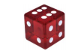

- Find the probability of rolling a dice showing divisors of 12.

- Find the probability of rolling a dice showing a 3 or greater.

- Find the probability of not rolling a pair of dice showing sum of 10 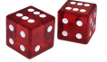

- Find the probability of not rolling a pair of dice showing a sum of 7

- Find the probability of rolling a pair of dice showing the difference of 3

- 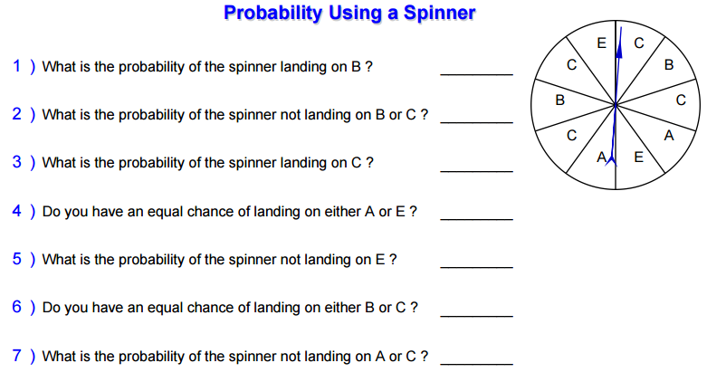

- A month is chosen from a year. Find the probability of selecting March.

- A month is chosen from a year. Find the probability of selecting a month either starting with the letter M or J.

- 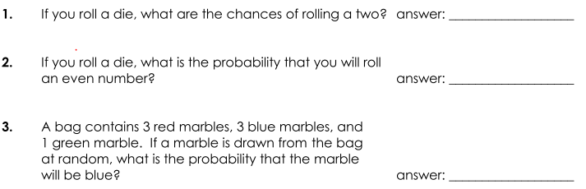

- Jazmin has a coin, and Sue has a standard 6-sided die. Jazmin flips the coin, and Sue rolls the die. What is the probability that Jazmin will flip a head and Sue will roll an even number?

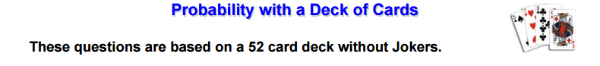

- Find the probability of drawing a 4 through 8 on the first draw, replacing it and drawing a red card on the second draw.

- Find the probability of drawing a red face card on the first draw, replacing it and drawing a 3 card on the second draw.

- Find the probability of drawing a 2 through 8 on the first draw, replacing it and drawing a 4 card on the second draw.

- Find the probability of drawing a red card on the first draw, replacing it and drawing a Club card on the second draw.

- Find the probability of drawing a Spade 3 through 9 on the first draw, replacing it and drawing a black card on the second draw.

